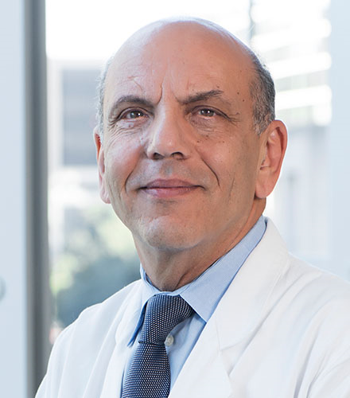 | A. Osama Gaber, MD, FACS, FAST  Founding Director, J.C. Water Jr. Transplant Center  Presidential Distinguished Chair, John F. Jr. and Carolyn Bookout  Chair, Department of Surgery, Houston Methodist Hospital  Senior Member, Houston Methodist Research Institute  Professor of Surgery, Weill Cornell Medical College

A. Osama Gaber, M.D., is the Chair of the Department of Surgery at Houston Methodist Hospital, the John F. Jr. and Carolyn Bookout Presidential Distinguished Chair, and the Founding Director of the J.C. Walter Jr. Transplant Center.
Dr. Gaber is a Professor of Surgery, Weill Cornell Medical College, and a Senior Member of the Houston Methodist Research Institute.
Dr. Gaber earned his medical degree from the Ainshams University School of Medicine in Cairo, Egypt, and subsequently, completed surgical training in general surgery at Boston University and research clinical transplant fellowships at the University of Chicago. He has devoted much of his career to pancreas, liver, kidney, and islet transplantation.
Dr. Gaber is author of more than 400 papers, 340+ abstracts, and numerous book chapters and has received research funding from several national and local foundations. He founded Nora’s Life Gift Foundation to build Nora’s Home in the Texas Medical Center, a hospitality home established to provide transplant patients and their families affordable temporary housing where they can find encouragement and support within a family environment.
Dr. Gaber is an active member of several major transplant organizations and currently is the Immediate Past President of the American Society of Transplant Surgeons (ASTS) and the Texas Transplantation Society. He previously chaired the Texas Governor’s Chronic Kidney Task Force and remains committed to this effort.
Dr. Gaber has had long experience in cellular transplantation, islet isolation preservation and culture, neo-islet generation from stem cells, and functional examination of β cells. Under his leadership, the Houston Methodist J.C. Walter Jr. Transplant Center quickly rose to be the largest in the State of Texas and one of the largest in the country. He has created a major research program in transplant immunology and cellular therapeutics and organ bioengineering.

