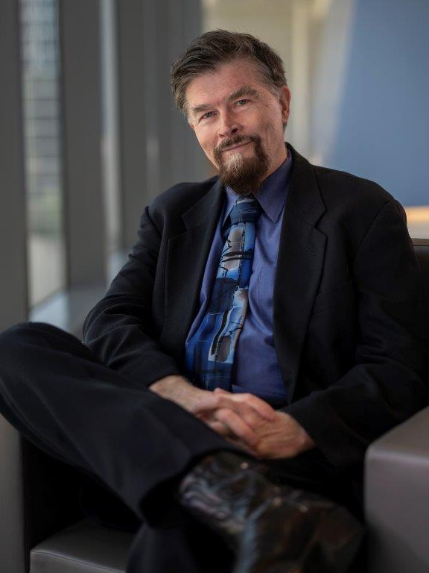 | JOHN P COOKE MD PHD  Joseph C. "Rusty" Walter and Carole Walter Looke Presidential Distinguished Chair  in Cardiovascular Disease Research  Founding Director, Center for RNA Therapeutics  Professor and Chair, Department of Cardiovascular Sciences  Chief Translational Science Officer  Houston Methodist Research Institute

Academic background.
Dr. Cooke trained in Cardiovascular Medicine at the Mayo Clinic and obtained a Ph.D. in Physiology there. Subsequently, he became a faculty member at Harvard Medical School, and then Stanford University where he was Professor and Associate Director of the Stanford Cardiovascular Institute until his recruitment to the Houston Methodist Research Institute (HMRI) in July 2013.

Research Program.
Dr. Cooke chairs the Department of Cardiovascular Science which generates fundamental insights that transform cardiovascular care. The basic science effort in angiogenesis, atherosclerosis, vascular regeneration, and cardiomyocyte function are carried out by nine faculty using a range of molecular, cellular, physiological, bioinformatics tools and technologies. In addition, the Department of Cardiovascular Sciences provides the infrastructure for about 200 industry-sponsored and investigator-initiated trials in cardiovascular diseases.

Dr. Cooke also directs the Center for RNA Therapeutics. Dr. Cooke’s team developed methods for the synthesis, purification, validation, lyophilization, and delivery of mRNA, and makes RNA constructs for investigators world-wide. Dr. Cooke has explored the use of mRNA encoding human telomerase to reverse senescence and to improve cell therapies. His regenerative medicine research is funded by the NIH, NASA, BARDA, AHA, CPRIT and industry. Dr. Cooke has published > 500 research papers, reviews, and patents (>35,000 citations; h index = 103; Scopus 4-11-23). He was named an Outstanding Inventor of 2015 by the Office of Technology Transfer at Stanford University and elected to the National Academy of Inventors in 2019; and received the Mayo Clinic Distinguished Alumni Award in 2020. His Center for RNA Therapeutics received the 2021 Innovation Award from the Houston Business Journal; the 2021 Best Academic Team Research, Vaccine Industry Excellence Award, at the 2021 World Vaccine Congress; and the 2022 Fire Award, Houston Business Journal, Top Health Care and Life Science Innovators.

