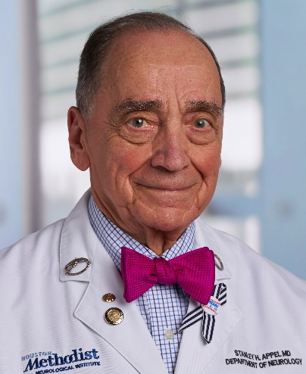 | Stanley H. Appel, MD  Director, Johnson Center for Cellular Therapeutics,  Edwards Distinguished Endowed Chair in ALS Research,  Houston Methodist Research Institute  Director, MDA/ALSA ALS Research and Clinical Center,  Stanley H. Appel Department of Neurology,  Houston Methodist Neurological Institute  Professor of Neurology, Weill Cornell Medical College
Stanley H. Appel, M.D. is the Director of the Johnson Center for Cellular Therapeutics, and the Peggy and Gary Edwards Distinguished Endowed Chair in ALS Research at Houston Methodist Hospital, and Professor of Neurology at Weill Cornell Medical College. He was previously Chief of the Neurology division and the James B. Duke Professor of Medicine at Duke University Medical Center, followed by Chair of the Department of Neurology at Baylor College of Medicine and Chair of the Stanley H. Appel Department of Neurology at Houston Methodist.
Dr. Appel received his bachelor’s degree at Harvard University and his medical degree from Columbia College of Physicians and Surgeons. He is Emeritus member of the Board of Directors for the Muscular Dystrophy Association, Chair of the Research Advisory Committee, and a member of the Board of Directors of ALS Therapy Development Institute. He is Director of the MDA/ALSA ALS Research and Clinical Center at Houston Methodist Neurological Institute, and past Director of the National Institute of Aging Alzheimer’s Disease Research Center.
He is the author of 15 published books and over 450 articles on ALS, neuromuscular disease, Alzheimer disease, and Parkinson’s disease. He has received numerous awards for his accomplishments in Neurology and Biochemistry, including the Gold Medal Award from Columbia College of Physicians and Surgeons for “Distinguished Achievements in Medicine”, the Sheila Essey Award from the American Academy of Neurology for “outstanding research in Amyotrophic Lateral Sclerosis”, the Norris Award from the Alliance of ALS/MND Associations, and the Houston Academy of Medicine John P. McGovern Compleat Physician Award.
Research in Dr. Appel’s laboratory has focused on the role of neuroinflammation in neurodegenerative diseases. In Amyotrophic Lateral Sclerosis, Parkinson Disease and Alzheimer Disease, neuroprotective regulatory T lymphocytes (Treg) are dysfuntional, and activated macrophages/microglia promote neuroinflammation. Expansion of Tregs ex vivo restores the suppressive functions, and has formed the basis of two clinical trials of autologous infusions of expanded Tregs. Each of these trials has indicated a promising benefit of Treg therapy.

